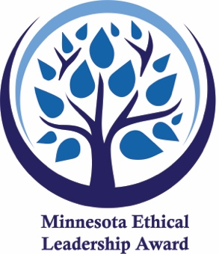
2024 Minnesota Ethical Leadership Award Nomination

The Minnesota Ethical Leadership Award honors community programs developing outstanding character and ethical leadership in its participants. Nomination deadline is Dec. 1, 2023. Email your nomination to Barb at bbergseth@synergyexchange.org or place a nomination online at https://forms.gle/WHuvx5BUHv92aWHw6

Nominator Information
This information is used to confirm or clarify your nomination.

Name:

Phone: Email:

Which option best describes your relationship to the nominee:

I work/volunteer for the program or organization I am nominating
I am a board member of the program or organization I am nominating
I am a participant of the program I am nominating
I am a supporter of the program I am nominating

I Nominate
Program Name:

Organization Name:

Address:

City: Zip Code:

Program Contact Name: (first and last)

Contact Title:

Contact Email: Contact Phone:

My reasons for nominating this program:
Please include how the work affects the development of good character and ethical leadership in the program participants. (please write on back of sheet if needed)

Synergy & Leadership Exchange ● 2075 Lookout Drive, North Mankato, MN 56003 ● www.synergyexchange.org

